Naval Support Facility Dahlgren Chapel

Jumu’ah Prayer Service

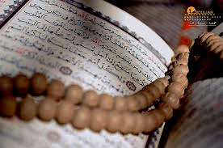
Every Friday @ 1330

For Details, Call Bro. Solomon (Slim) 540.413.4333 slimah.amranie@navy.mil

Office: 540.653.8297
After Hours: 540.413.7029
Email: DAHLGRENCHAPELFCT@US.NAVY.MIL

